

# 

# 

# Mitigating Insider Threats:

1. Define - Determine what an insider is as well as the many forms it can take on
2. Detect & Identify - Using both human and technological elements, monitor and identify potential threats
3. Assess - Using all known information, follow the response plan that aligns with the scenario
4. Manage - Continue to be proactive and manage an threat or potential threat

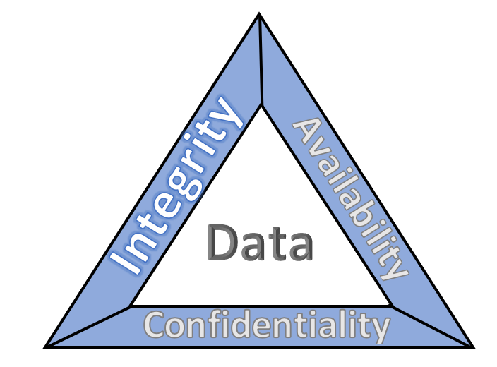

# 

# 

# 

# Resources:

[CISA](https://www.cisa.gov/insider-threat-mitigation) - Insider threat mitigation information

[NIST](https://www.nccoe.nist.gov/publication/1800-25/VolA/index.html) - Data integrity

[NIH](https://www.ncbi.nlm.nih.gov/pmc/articles/PMC9044369/) - Preventing insider threats